Fundamental restriction on epistasis detection
and fitness valleys in virus evolution
Likhachev I.V. & Rouzine I.M.*
Sechenov Institute of Evolutionary Physiology and Biochemistry
Russian Academy of Sciences, St Petersburg, Russia

ABSTRACT
Probabilistic prognosis of virus evolution, vital for the design of effective vaccines and antiviral drugs, requires the knowledge of adaptive landscape including epistatic interactions. Although epistatic interactions can, in principle, be inferred from abundant sequencing data, fundamental limitations on their detection imposed by genetic linkage between evolving sites obscure their signature and require averaging over many independent populations. We probe the limits of detection based on pairwise correlations conditioned on the state of a third site on synthetic sequences evolved in a Monte Carlo algorithm with known epistatic pairs. Results demonstrate that the detection error decreases with the number of independent populations and increases with the sequence length. The accuracy is enhanced by moderate recombination and is maximal, when epistasis magnitude approaches the point of full compensation. The method is applied to several thousands of sequences of SARS-CoV-2 sampled in three different ways. Results obtained under equal sampling from world regions imply the existence of fitness valleys connecting groups of viral variants.

Keywords: epistasis, epistasis detection, genetic linkage, respiratory virus, virus evolution, mathematical model

* Correspondence should be addressed to: igor.rouzine@iephb.ru

SIGNIFICANCE
The few epistatic pairs of genomic sites hide in genomic data among numerous random correlations caused by common phylogenetic history. We test a method of epistasis detection designed to compensate for this noise. The accuracy is tested using synthetic sequences generated by a Monte Carlo algorithm with known epistatic pairs. The method is applied to several thousands of sequences of SARS-CoV-2 sampled in three different ways. Results obtained under equal sampling from world regions imply the existence of fitness valleys connecting groups of viral variants.

INTRODUCTION
Elucidating the connection between genotype and phenotype remains a challenging problem. Most traits in organisms are coded by several genomic sites, whose combined effect on the phenotype is not a sum of their effects, but also includes site-site interaction termed “epistasis”. Epistasis is responsible for a significant fraction of genetic inheritance [1, 2]. In pathogens, epistasis facilitates the development of drug resistance and immune escape and impedes reversion of drug-resistant mutations [3-7]. Mutations in epitopes assisted by epistasis help a pathogen to escape the cytotoxic immune response in the host, when viral replication capacity lowered by an escape mutation is gradually restored later by compensatory mutations [8-11]. This process, termed fitness valley, is thought to be responsible for the high diversity and rapid HIV evolution in untreated patients [12].
Epistasis is also implicated in the evolution of variants of SARS-CoV-2 [13]. Some mutations in neutralizing antibody-binding regions that help SARS-CoV-2 to escape immune recognition during transmission [14-18] negatively affect the function of receptor binding, and have to be compensated elsewhere [19]. The tradeoff between antibody escape and transmissibility has been inferred in immunocompromised patients [20]. The same is likely true for mutations conferring escape from innate responses to SARS-CoV-2 [21, 22]
While pairwise epistasis can be measured from the free energy of binding [23] and in culture [24], these results cannot be transferred directly to the biological levels of an organism or population, where epistasis is defined with respect to fitness, i.e. the reproduction number at the within-host or between-host levels. Therefore, a large number of approaches has been proposed to measure epistasis directly from genomic data [25-27]. A popular method of “quasi-linkage equilibrium" assumes that recombination is rapid compared to allele frequency changes, and that population is large, so that recombination and the natural selection with epistasis are the dominant evolutionary factors, while the effects of genetic linkage are relatively small [28-31]. However, none of these methods enable reliable measurement of epistasis in asexual populations or in sexual populations at close loci [32].
About a century ago, it was realized that the evolution of a population is strongly affected by the fact that the fates of alleles at different loci are linked unless separated by recombination [33]. Empirically, the effect of strong linkage between genomic sites has been discovered by Thomas Hunt Morgan who used the inter-dependent segregation of alleles in fruit flies to understand the role of chromosomes and sex in inheritance. Since then, a large body of experiment and modeling demonstrated that linkage changes evolutionary properties drastically. In the absence of recombination, common phylogeny makes all sequences very similar to their MRCA [34]. Moreover, even very frequent recombination does not break up linkage effects in a sufficiently long genome [35].
The increasingly dominant effect of linkage over epistasis in allelic associations originates from the genetic divergence of independent populations in time. All sequences in a population are similar to their most recent common ancestor, which moves away from the origin along a stochastic trajectory [34]. As a result, any measure of co-variance produces strong noise of random sign. An attempt at detecting epistasis, whether by using covariance measures, such as Pearson coefficient, mutual entropy, universal footprint [36], or by tree-based methods [37, 38] faces the same problem, the overwhelming genetic linkage effects. The only way to resolve this issue is to average the haplotype frequencies over many independent populations evolving under similar conditions. To decrease the required number of populations, it was proposed to use only sequences with a majority allele at a neighbor site of the measured site pair to interrupt a path along sites that creates a false-positive interaction [39].
In the present work, we test the fidelity of this detection technique using Monte-Carlo simulation in a broad range of parameters. Then, we apply the method to real virus sequences from the adapting world population of SARS–CoV-2 sampled in three different ways to predict the strongest epistatic links. This approach differs from the alternative methods in the following respects. Firstly, it does not make unrealistic assumptions regarding the evolutionary factors at play. Secondly, its accuracy is validated in a broad range of model parameters on simulated sequences, using a generic model of population genetics of the Wright Fisher type. Thirdly, the application to data is focused on well-balanced sampling between sequences related to major variants. The fourth feature is the use of the conditional correlator.

RESULTS
Detection method. The method is based on the calculation of Universal Footprint correlator between pairs of loci [Pedruzzi2018]. This correlator, expressed in terms of haplotype frequencies by applying the second law of thermodynamics to a multi-locus evolutionary model, depends only on epistasis magnitude and its topology, but not on any other evolutionary parameters. The method takes a set of binarized sequences as initial data. We employ parallel computing on 10,000 processors of GPU to increase performance. To improve detection accuracy near the point of full compensation, an additional correlator conditioned on an allele at a third locus is calculated. Based on the relationship between the two correlators, an epistatic interaction between the two loci is inferred. The details are described in Methods.
Accuracy test 1: the case of standing variation. To test the accuracy of the detection method, artificial genomic sequences are obtained from the simulation of the multi-site evolution of a genetically-diverse population by a Monte-Carlo algorithm with a set epistasis network (Methods). The input parameters are chosen in a range representative for several viruses (Table 1 in Methods). The predicted links are compared with the true links set in the algorithm. The error of detection is defined as the number of false-positive and false-negative interactions among predicted interactions divided by the number of true interactions. The error is calculated as a function of several parameters: genome length (total locus number), the number of independent populations used for averaging haplotype frequencies, the magnitude of epistasis, recombination probability, and the average crossover number (Fig. 1).
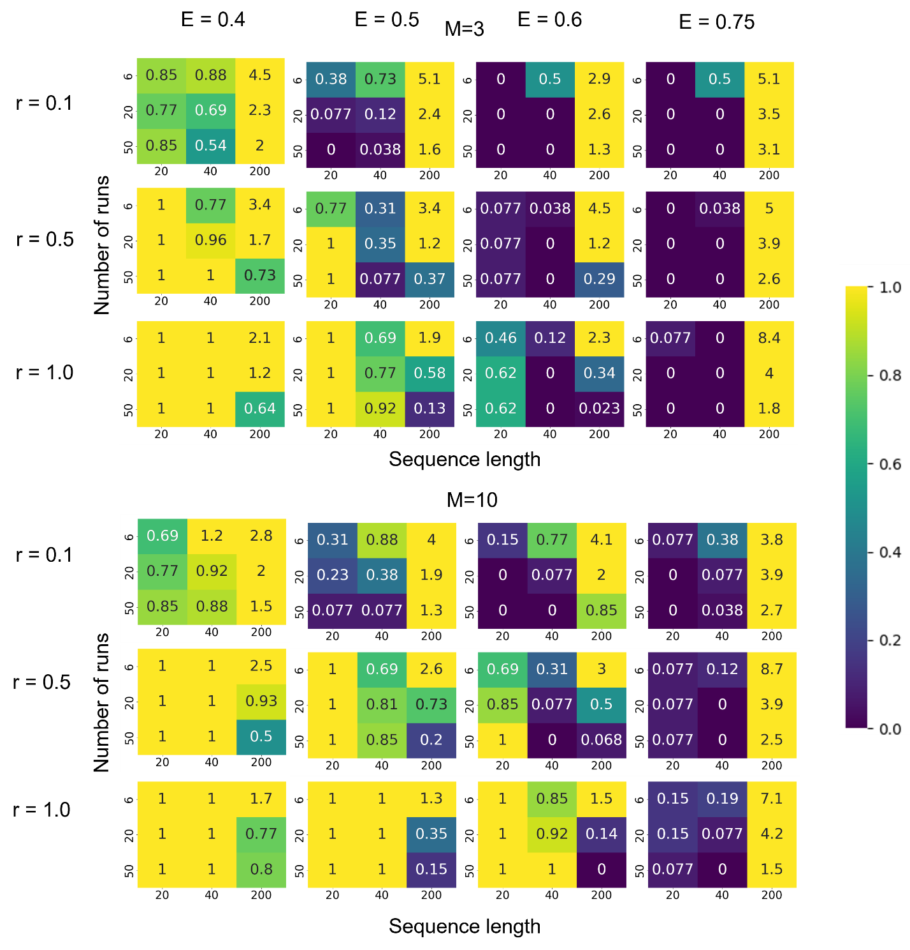
Figure 1. The error of detection of epistatic interactions for the case of standing variation (Test1). The length of the sequence is plotted on the X–axis, and the number of runs is plotted on the Y-axis of each panel. The values inside the squares defined by color map on the right correspond to the sum of the false positive and false negative interactions divided by the number of true interactions. Detection is carried out using the universal footprint of epistasis (UFE) [36] and three-site haplotype method [39] (Methods). All values greater than 1 are set to have the same red color as values equal to 1. Testing of the method was conducted on the sequences generated by Monte Carlo simulation (Methods) with variable parameters (shown): probability of recombination $r$, number of crossovers $M$, strength of the epistatic interaction $E$. The topology of the epistatic links (interactions) comprises isolated double arches, for which $E=0.75$ is the threshold value of full compensation [36]. Fixed parameters: initial allele frequency $f_{0}= 0.45$, population size $N = 1000$, mutation rate per genome $μL = 0.07$, simulation time in generations $t = 30$, selection coefficient $s = 0.1$. Results for $M=1$ are shown in Figure S1. Variant without recombination is shown in Figure S2. Results using Pearson coefficient, with and without recombination, are in Figs. S3 and S4.

As expected, the accuracy of epistasis detection increases with the number of independent populations used for averaging and the magnitude of epistasis, and decreases with the genome length, as long as recombination is infrequent or absent. While modest recombination significantly improves the accuracy of detection by compensating linkage effects eclipsing epistasis, very frequent recombination counteracts associations of alleles caused by epistasis and so impairs detection (Fig. 1). Analogous procedure was carried out using Pearson coefficient and UFE [36] in the absence of recombination (Supplement, Figs. S2-S4).
Accuracy test 2: initially monomorphous population with fitness valley. In real world, not all populations are polymorphous in the beginning of evolution. Therefore, we carried out an additional simulation test with initial allelic frequency at each locus $f_{0}=0$. The epistatic network was changed from the isolated double arcs to a single star comprising one deleterious allele and 10 rays with compensatory alleles. Recombination is absent.
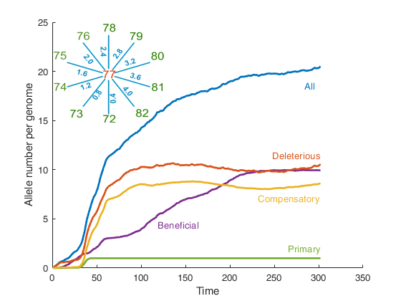
Figure #. Monte Carlo simulation of the evolutionary dynamics of a population with a fitness valley. X-axis: Time in generations. Y axis: Average numbers of the alleles of different classes (shown) per genome. Parameters: initial allele frequency $f_{0}= 0$, population size $N = 1000$, mutation rate per genome $μL = 0.1$,10% of the alleles are beneficial, 90% are deleterious with selection coefficient $s = 0.1$ . Epistatic network represents a star with the primary allele in the center and ten compensatory mutations as the rays, all of which are deleterious as single alleles. Epistatic parameters are given in Methods Recombination is absent.

Initially, population is monomorphous. Then a gradual accumulation of beneficial alleles occurs, which are assumed to take 10% of loci. Deleterious alleles accumulate at the remaining 90% of loci more slowly due to the hitchhiking effect, i.e., genetic linkage with the beneficial alleles. Among deleterious alleles, one is set to be the primary mutation of fitness valley and 10 are set to be compensatory mutations with the degrees of compensation ranging from 80 to 800%. These mutations are deleterious separately, but the combination of the primary allele with the compensatory alleles is selectively advantageous. Sooner or later, deleterious primary mutation becomes abundant in a population due to the hitchhiking effect. Then compensatory alleles become advantageous, and start rapid accumulation, leading to a jump in the curve (Fig. #). This marks passing the fitness valley and the emergence of a new group of virus variants on the end of fitness valley.
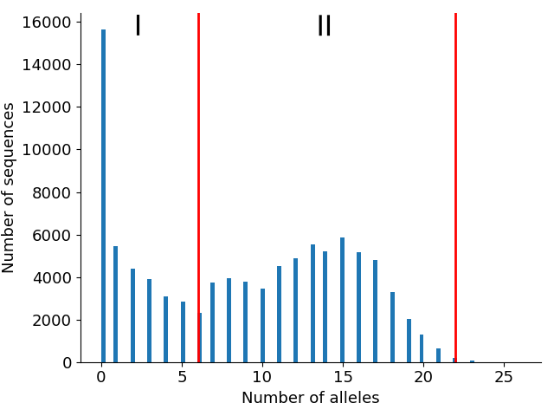
Figure ** . Mutational spectrum for initially-monomorphous populations. Y–axis: number of sequences with a given number of differences (X–axis) from the initial sequence. Red lines at ​​​​6 and 22 divide the two groups of sequences numbered by Roman numerals Simulation parameters are the same as in Figure #, but 6 Monte Carlo runs and each 10th timepoint till t = 150 are used.

As a result of virus passing the fitness valley, the mutational spectrum averaged over 6 populations at 150 generational steps had two maxima (Fig. **). The sequences were divided between the two peaks with borders chosen at 6 (the local minimum) and 22 new alleles (upper cutoff). Then we conducted bootstrapping procedure, in which sequences from each peak were oversampled many times with replacement and repetition. The resulting samples were used for the epistasis detection method described above.
The resulting detection error is calculated as the sum of false positive and false negative epistatic interactions out of 10 possible (Fig. ***), as a function of numbers of sequences sampled from peak 1 and 2, normalized to the sequence number of each peak. The number of false positive interactions remained zero, so that the total error was given by false negatives only . Therefore this method is highly accurate, but only in the conservative direction. Our results suggest the need to take either equal sampling from the two peaks or somewhat smaller sampling from the earlier peak (Peak I), as long as they are approximately equal in size, as in our example.
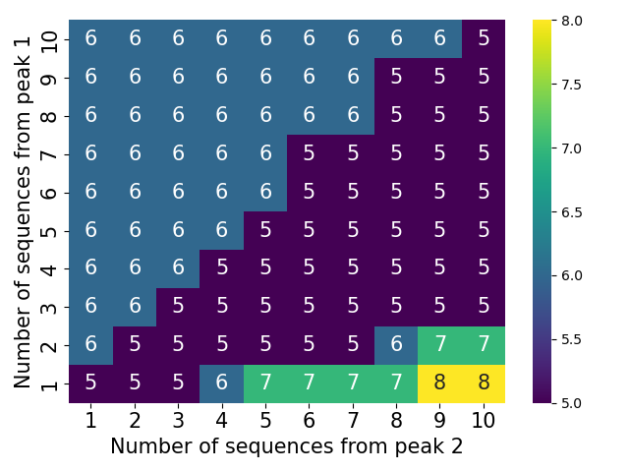
Figure *** . Error of epistatic detection for simulated Test 2 (initial monomorphic population). Axes X and Y show the numbers of sequences sampled from Peak 1 and Peak 2 in Fig. **, respectively, relative to the size of each peak.. Numbers in cells show the sum of false positive and false negative epistatic interactions out of 10 possible. At all cells, the number of false positives is zero. Parameters are as in Figure#.

Results on epistasis detection in genomic data for SARS CoV-2 are consistent with fitness valleys. After testing the method on simulated sequences, we applied it to sequence data on SARS-CoV-2 for three different data sets, as follows.
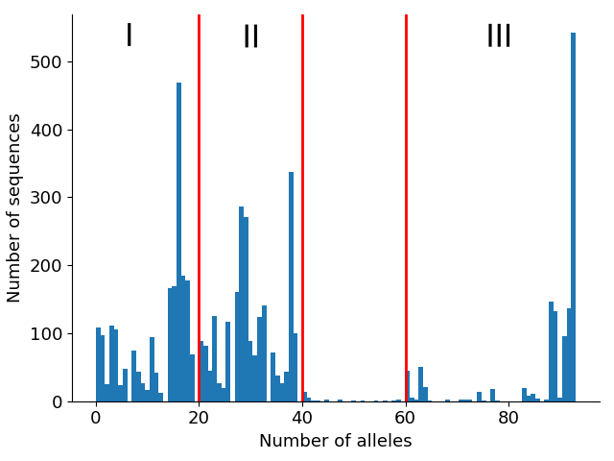
Figure 2. Mutational spectrum for Dataset 1. Y–axis: number of sequences with a given number of differences (X–axis) from the consensus sequence of the entire dataset. Red lines at ​​​​20,40 and 60 divide the three groups of sequences numbered by Roman numerals. See Methods for details.

Dataset 1 includes 6000 sequences from 6 regions, 1000 from each: Africa, Asia, North America, Oceania, South America, for the period of one year, 09/24/2020 to 09/25/2021. When each sequence is compared to the common consensus sequence of the dataset, a mutation spectrum is obtained, where sequences segregate naturally into three groups, with gaps between them (Fig. 2). Random sets of different size were resampled 200 times from groups I and II in Fig. 2.
The central panel in Fig. 3 shows the number of detected epistatic interactions, as a function of the numbers of sequences sampled from groups I and II (Methods). Epistatic networks are shown for four choices of sampling sizes corresponding to points A to D in the central panel (Figs. 3A-D). We observe that stable results are obtained if the two groups are sampled equally (Fig. 3A, D, blue dotted line). In contrast, unequal sampling from the two groups of interest introduces a large error in predicted number of epistatic interactions (Fig. 3B and C). This observation emphasizes the importance of equal sampling. In the same way, epistatic network was obtained for sequence groups I and III (Fig. 4). Again, equal sampling from the two groups ensures stable result (Fig. 4A, D).

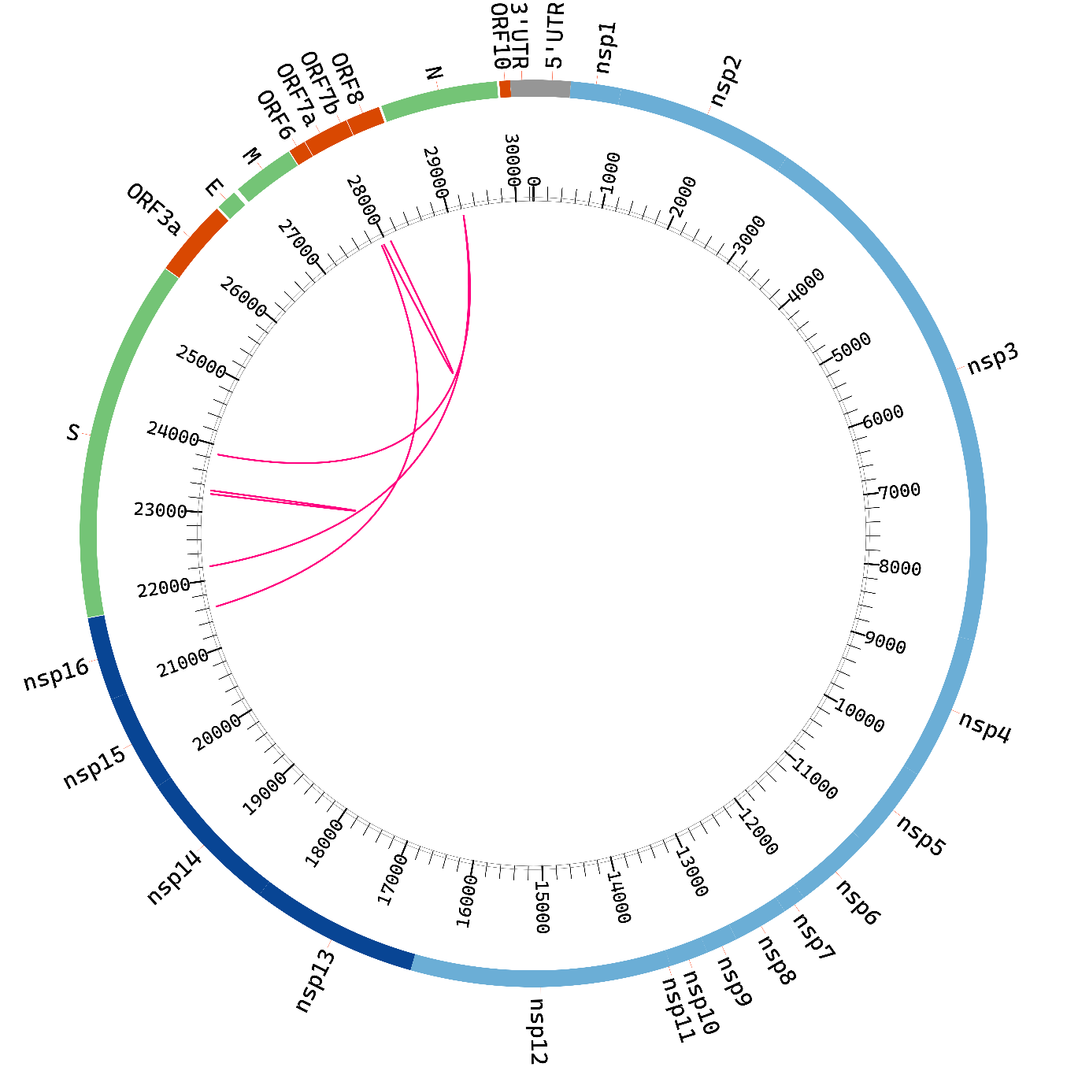

Figure 3. Epistatic interactions for SARS-CoV-2 genome predicted for Dataset 1 for sequence groups I and II. Circular diagram of connections sampling sizes are ten times total number of sequences each.Drawn by software Circos (add citation). The list of interacting pairs see in Supplementary Text S1.

Both networks (Fig. 3A or D and 4A or D) are consistent with the presence of fitness valleys, although do not demonstrate their existence directly due to the absence of weaker links not captured by the method. The method is conservative, and its accuracy at small epistatic magnitudes is low (Fig. 1). Hence the epistastic interactions found in Figs. 3 and 4 are the strongest in possible fitness valleys. The difference between the results obtained for pairs I-II and I-III (Figs. 3 and 4, respectively) can be interpreted as two different fitness valleys: one connecting variant group I to group II and another connecting I to III. For sequences sampled from groups II and III, no significant epistatic links are found, indicating the absence of a direct passage between them. The results we obtain are consistent with the existence of several fitness valleys connecting large groups of virus variants.
In Dataset 2, the same procedure was repeated for 12,000 sequences from NCBI Virus database labeled either B.1 or B.1.1.7 (Alpha), 6000 for each strain. Geography and sampling time was ignored. In Dataset 3, we used 20,000 random sequences from the NCBI Virus database for the same period of one year as Dataset 1, from 09/24/2020 to 09/25/2021. The results for Datasets 2 and 3 are presented in Supplement (Figs. S6 and S7). Unlike the case with Dataset 1, mutational spectra obtained for Datasets 2 and 3 do not have a clear separation into distinct sequence groups and are not consistent with fitness valleys. Overall, these results emphasize the importance of equal sampling from world regions (present in Dataset 1 but not Datasets 2 and 3).

DISCUSSION

Detection and measurement of epistasis from genetic data represents a challenge. In our work, we have upgraded a linkage-resistant method of detection and applied it to sequences from SARS-CoV-2. Results are consistent with the existence of fitness valleys that provide passages between large groups of virus variants.
As mentioned before, a fitness valley comprises a transient decrease in fitness due to initial mutation(s) forced by changes in the environment, which is followed by compensatory mutations. The fitness valley effect was previously observed or inferred for various viruses, including HIV [40, 41] and influenza [37-39], and studied using mathematical models [8, 39]. For example, a primary mutation can help a virus to escape the immune response, adapt to a species or a tissue, or expand the pH range in which it can replicate. Mutations conferring these benefits to a virus, but reducing its overall fitness, are followed by compensatory mutations that elevate its fitness above the initial level.
The loss of fitness due to escape mutations, and the partial loss of recognition by the immune system, together determine the order, the number, and the evolution rates of escape mutations in HIV infection [42, 43]. Compensatory mutations prevent the reversion of escape mutations after the decay of CD8 T cell clones against escaped epitopes. Bacteria developing antibiotic resistance also pass through such fitness valleys [5]. A population-level simulation study proposed this effect in conjunction with the evolution in immunocompromised patients infected with SARS-CoV-2 [44]. However, under certain conditions, a fitness valley could also be crossed in the general population, in direct patient-to-patient transmission.
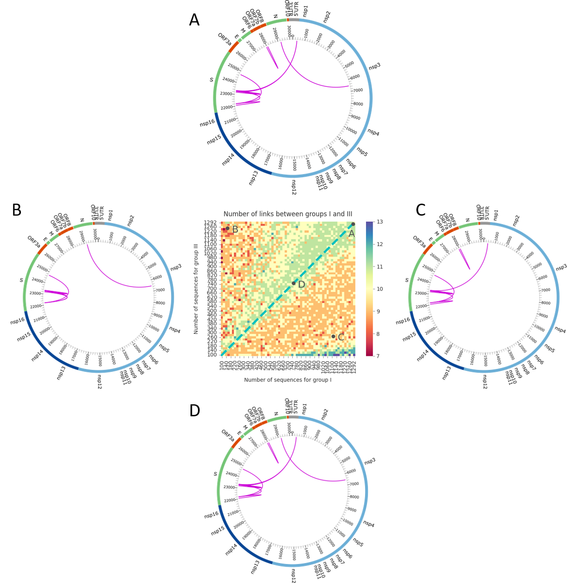

Figure 4. Epistatic interactions for SARS-CoV-2 genome predicted for Dataset 1 between groups I and III in Fig. 2. Notation as in Fig. 3. A variant of the diagram prepared without sequences around the peak centered at 90 in Fig. 2 is in Figure S5. The list of interacting pairs is in Supplementary Text S2.

The fates of alleles at different loci are linked due to common phylogeny unless separated by recombination [33]. For this reason, one-locus models usually do not apply in real populations, and multi-locus models must be used instead [45, 46]. These models, based on traveling-wave technique, have been successfully applied to rapidly-evolving viruses, such as HIV [47] and influenza [48-50] }. Linkage effects include clonal interference [33, 51], background selection, genetic hitchhiking [52], enhanced accumulation of deleterious alleles (Muller's ratchet) [53, 54], and the increase of genetic drift at one locus due to selection at another [55]. Multi-site adaptation has been analyzed analytically in various asexual models, with the result that linkage effects strongly decrease the adaptation rate compared to the limit of independently-evolving sites [54, 56-58]. Importantly, genetic linkage also creates random associations between pairs of mutations occurring on the same branch of the ancestral tree, which is a serious obstacle to the detection of epistatic interactions in genetic data [32]. In a single asexual population, stochastic linkage completely overshadows the epistatic footprint, except in a narrow range of times and parameters [34] }. The same limitation exists for the tree-based methods of detection [37, 38].
For testing the accuracy, we used a model with directional selection. In fact, SARS-CoV–2 evolves in antibody–binding regions due to collective immunity of population, which is a case of the selection for change (Red Queen effect). Nevertheless, as it has been shown by several groups [48-50], the multi-locus epidemiological model of respiratory viruses is effectively reduced to the Wright-Fisher model with constant directional selection. The selection coefficient is expressed in terms of basic reproduction ratio in a naïve population and the breadth of antibody neutralization, calculated in these works using different approximations.
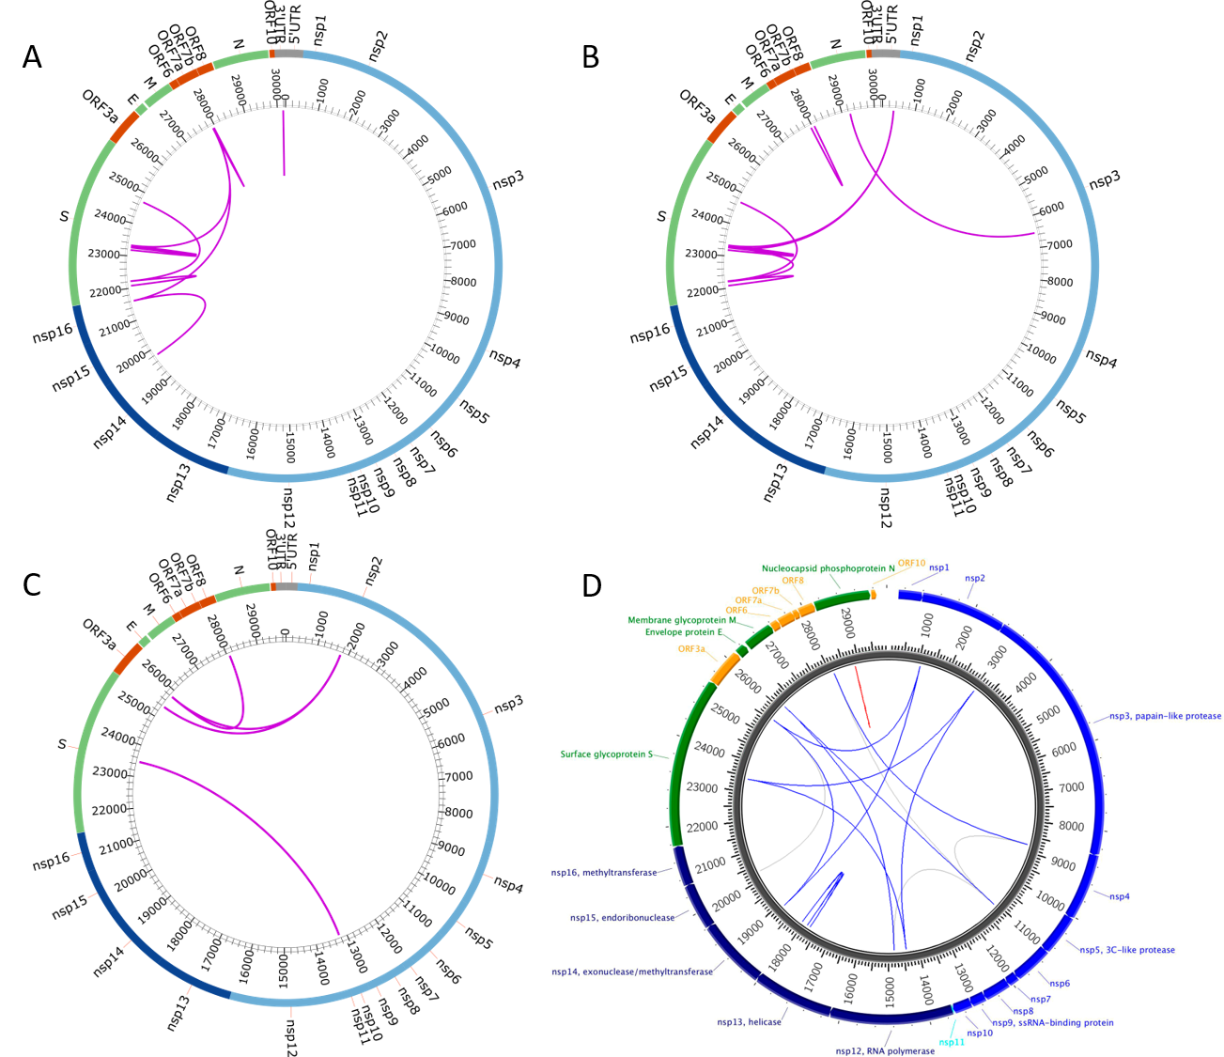

Figure 5. Epistatic interactions for SARS-CoV-2 genome: comparison of the present results with two previous studies. A) Results of the present work for Dataset 1, sequence groups 1 and 2 in Fig. 2, panel A or D in Fig. 3. B) The same, but for groups 1 and 3. C, D) Results from studies [59] and [60], respectively.

The most popular method for searching for epistasis signature in genomic data is the “quasi linkage equilibrium” approach [28, 30], which assumes frequent recombination compared to changes in allelic frequency and a large population size. In this limit, genetic linkage effects are negligible compared to epistasis and recombination. In the present work, we do not rely on QLE approximation, so that the method works for finite population size and for modest recombination or even in its absence. The linkage effects are mostly cancelled out by averaging over well-balanced independent populations and the use of 3-site haplotypes. Such cancellation was not carried out in [60], hence the abundance of false negative links (Fig. 5D) compared to our results (Fig. 5A, B).
To address the problem of false-negative bonds, another team [59] compared the sequences of SARS CoV-2 not between themselves, but with other coronaviruses. They used “direct coupling analysis”, which postulates a statistical distribution of sequences (usually, of a Gaussian form) including individual effects of alleles and their pairwise interaction. A physicist would recognize here the Gibbs distribution for the Onsager model of ferromagnetism. In population genetics, this Gaussian form has a justification in the limit of QLE [28, 30]. Parameters of the Gaussian are fit to sequence data using various approximations [59]. DCA also includes down-weighing sequences with over 80% identity, which is a phenomenological trick to deal with the effects of random linkage. As result, the number of false-positive epistatic bonds due to genetic linkage is sharply decreased (Fig. 5C). The DCA approach has other problems as well. Firstly, QLE approximation that lies at the basis of DCA was formulated for sequences from the same population of the same species, not from different species, and the validity of such a leap to cross-species comparison is not formally justified. Secondly, such an approach assumes that pairwise interactions did not change for million years since the most recent common ancestor of these species. Interactions of higher orders may be incorporated into pairwise interactions on short time scales, as done in our work as well, but such renormalized values are expected to change at long interspecies times. Thirdly, QLE does not work in SARS CoV-2 evolution, because linkage effects, which are negligible in QLE limit, are strong. Lastly, a population of infected individuals is not as large as required for QLE to work.
Note that the use of tree-based methods does not automatically compensate for strong linkage effects. This is because, in the absence of sufficiently strong recombination, all sequences in one single population are very similar to their MRCA, and MRCAs for different independent populations are diverging from each other in genetic space. This process was demonstrated to be responsible for strong linkage effects [34]. To exclude the effects of linkage, one group used synonymous sites as markers of linkage [37, 38]. However, the accuracy of this method was not tested in simulation.
To conclude, the present study confirms the existence of fundamental limitations on epistasis detection due to genetic linkage. Within this limitation, a conditional correlation method combined with balanced sampling from quasi-independent populations and testing the accuracy in simulation allows the testable detection of strong epistatic links.

METHODS

Generating sequences for method testing. Evolution of a haploid asexual population of $N$ binary sequences is simulated by a Monte Carlo code [36, 61], as follows. In an individual genome, each locus (site, nucleotide position, amino acid position) numbered $i =1, 2, …, L$ is occupied by one of two alleles, either the wild-type allele, denoted $K_{i}=0$, or the mutant allele, $K_{i}=1$.We use a discrete generation scheme in the absence of generation overlap (Wright-Fisher model). The evolutionary factors included in the model are random mutation with rate $μL$ per genome, constant directional selection, random genetic drift due to random sampling of progeny and recombination with rate $r$. Selection includes an epistatic network with a set strength and topology. The logarithm of the average progeny number of a genome, $W,$ depends on sequence $[K_{i}]$ as given by [36]
$W\left[K_{i}\right]=-\sum_{i=1}^{L}{s_{i}K_{i}}+\sum_{i<j}^{L}{s_{ij}K_{i}K_{j}} (1)$
$$s_{ij}=E_{ij}\left(s_{i}+s_{j}\right)T_{ij} (2)$$
where $T_{ij} =0$or$1$ is the binary matrix that shows interacting pairs. Here the selection coefficients $s_{i}$ and $s_{j}$denote the individual fitness costs of two deleterious mutations, $E_{ij}$ is the compensation degree at sites $i$and $j.$
In our simulation example in Fig 1, we consider a haploid population with the initial frequency of deleterious alleles $f_{0}=0.45,$ mutation rate per genome $μL=0.07,$fixed selection coefficient$s_{i}≡s =0.1,$population $size N=1000$ individuals and genome length $L=40$sites.
The Monte-Carlo simulation code is written in MATLABTM and deposited at https://github.com/FireFrog17/Fundamental-restriction-on-epistasis-detection-and-fitness-valleys-in-virus-evolution-Data

Table 1. Parameters of the model and data processing.
Notation | Value | Description
$$f_{0}$$ | 0.45 | Initial proportion of mutant alleles in the population
$$N$$ | 1000 | Population size
$$μL$$ | 0.07 | Mutation rate per genome
$$t$$ | 30 | Simulation time in generations
$$s_{0}$$ | 0.1 | Selection coefficient (the same for all sites)
$$r$$ | [0,0.1,0.5,1] | Recombination probability
$$M$$ | [1,3,10] | Number of crossovers
$$E$$ | [0.4,0.5,0.6,0.75] | Strength of epistatic interaction
$$run$$ | [6,20,50,200] | Number of simulation runs used to average the data
$L$ (seqlen) | [20,40,100,200] | Length of the simulated sequence
Sequence threshold | [0.7] | Maximum proportion of gaps and nonreads in one sequence
Gap threshold | [0.5] | Maximum proportion of gaps and nonreads at one site
Monomorphism threshold | [0.8,0.95] | Maximum degree of monomorphism per site

Processing genomic data of SARS-CoV-2. In Dataset 1, 6000 sequences sampled from 6 regions (Africa, Asia, North America, Oceania, South America) in the period from 09/24/2020 to 09/25/2021 were downloaded from database NCBI Virus. In Dataset 2, 12,000 sequences were sampled from NCBI Virus database labeled B.1 and B.1.1.7 (Alpha), in equal numbers for each label. In Dataset 3, we used 20,000 random sequences from the NCBI Virus database for the period from 09/24/2020 to 09/25/2021.
The sequences were not stratified by sampling date for two reasons, as follows. Firstly, the necessary size of statistics would be missing. Also, previous experience with hemagglutinin data [39] demonstrates that combining sequences from different dates is an advantage, because one compares earlier and later strains and thus finds a fitness valley connecting them. In contrast, estimation of selection coefficients, indeed, requires classification by time [62] .
Downloaded data were processed by a custom-made sequence-processing program ProcessGenomes.py. Multiple alignment was performed in MAFT online, using the "Fast calculation of full-length MSA of closely related viral genomes [63]. From the total number of downloaded and aligned sequences, sequences in which the percentage of symbols “–“ (gap) or “N” (nonread) is greater than Sequence threshold are removed. From the remaining sequences, sites in which the percentage of gaps or letters N in across sequences is higher than Gap threshold are removed. Then, sites with a polymorphism degree (Hamming distance) lower than Monomorphism threshold are removed. We put the monomorphism threshold at two values (Table 1) and make sure that the choice does not affect final results, i.e., results are in a plateau in this parameter. The sequence data are binarized: the consensus variant is declared 0, the others are 1, with the resulting population matrix $K_{ni}$.
After binarization, the sequence data of virus undergo an additional processing stage, as follows. Based on the number of differences from sample consensus, a mutational spectrum is constructed using a custom-made sequence processing program ProcessGenomes.py (Fig. 2). Several groups of sequences are identified from this diagram. The new matrix $K_{ni}$ is formed by random sampling from two chosen groups, with the possibility of repetition. Averaging is performed over 200 random samples. The dependence of the predicted number of epistatic links on the sample size of each group is shown as a color map in the center of Figs. 3 and 4.
Epistasis detection and measurement. Based on matrix $K_{ni}$ obtained as described above, the universal footprint of epistasis [36] denoted $UFE_{ij}$ is calculated for each possible pair of sites $i,j$ as $UFE_{ij}=1-log\left(\frac{f_{11}}{f_{00}}\right)/log\left(\frac{f_{01}f_{10}}{f_{00}^{2}}\right).$ Then, the conditional coefficient $UFE_{ij0}$ is re-calculated for each locus pair [39], as follows. Only sequences where at least one of the neighboring loci of the pair has allele 0 are used. The minimum of all UFE over such neighbors is denoted $UFE_{ij0}$. Because the array of data used is large, these coefficients are calculated using parallel computing on the video card with more than 1000 parallel processors with the help of CUDA language. Pairs of loci, where the ratio of $UFE_{ij}$ to $UFE_{ij0}$ is equal to or greater than 0.5, are considered “true pairs”, while the remaining pairs are excluded. Results are displayed in the form of circular diagrams (Figs 3 and 4).
Error calculation. The estimated epistatic pairs are compared with the matrix of true pairs $T_{ij}$ set in the Monte Carlo simulation code that generates genomic sequences for testing the accuracy. The relative error of the method is calculated as the sum of the number of false positive and false negative pairs divided by the total number of true pairs.
Assumptions and approximations. The method implies the weak selection limit, defined as $max(1/N, μ) ≪ s ≪ 1$, and is appropriate in the travelling wave regime, when many mutations at different loci are being fixed gradually and compete with each other for the space in population (clonal interference). The traveling wave regime takes place at $NμL≫1$ and on time scales longer than $1/s.$
Next, the fluctuations of mutation rate along the genome, which are typically strong for RNA viruses, do not matter much in the multi-site evolution regime, where the mutation rate enters all the observables in the argument of a large logarithm [45].
Recombination is relatively rare in SARS-CoV-2, because it requires coinfection of an individual with two genetically remote variants, as estimated before for another virus [61, 64]. Multiplicity of infection is incorporated into an effective recombination rate measurable directly from genomic data [61, 65].
Also, here we consider the population level evolution only, because SARS–CoV-2 is acute and represented by a single variant in 99,5% patients, similar to influenza. In principle, the 0.5% chronic patients could seed new variants, in which case inter-scale evolutionary conflicts are possible [66].

Funding. The study was funded by Russian Science Foundation, grant 24-24-00529.
Acknowledgements. We thank A.A. Makashov and S.V. Lagunov for technical help and discussion. We are grateful to A. I. Pikhulya, D. A. Gorshkova, E. A. Vigovskaya, and E. I. Stroganova for technical help.
Conflict of interests. Authors declare no conflict of interest.
Ethical statement. No ethical statement is required.
Availability of data and software. Codes are available at https://github.com/FireFrog17/Fundamental-restriction-on-epistasis-detection-and-fitness-valleys-in-virus-evolution-Data
Supplementary material
Text S1. List of interacting pairs from Fig 3.
Text S2. List of interacting pairs from Fig 4.
Figure S1. Accuracy of detection of epistatic pairs from UFE correlator for $M=1$.
Figure S2. The error of detection of epistatic interactions in the absence of recombination (UFE).
Figure S3. The error of detection of epistatic interactions (Pearson).
Figure S4. The error of detection of epistatic interactions in the absence of recombination (Pearson).
Figure S5 А variant of Fig. 4
Figure S6. Epistatic interactions for SARS-CoV-2 genome predicted for Dataset 2
Figure S7. Epistatic interactions for SARS-CoV-2 genome predicted for Dataset 3

REFERENCES

1. O. Carlborg, L. Jacobsson, P. Ahgren, P. Siegel, L. Andersson, Epistasis and the release of genetic variation during long-term selection. Nat Genet 38, 418-420 (2006).
2. O. Zuk, E. Hechter, S. R. Sunyaev, E. S. Lander, The mystery of missing heritability: Genetic interactions create phantom heritability. Proc Natl Acad Sci U S A 109, 1193-1198 (2012).
3. D. B. Weissman, M. M. Desai, D. S. Fisher, M. W. Feldman, The rate at which asexual populations cross fitness valleys. Theor Popul Biol 75, 286-300 (2009).
4. E. Gonzalez-Ortega, E. Ballana, R. Badia, B. Clotet, J. A. Este, Compensatory mutations rescue the virus replicative capacity of VIRIP-resistant HIV-1. Antiviral Res 92, 479-483 (2011).
5. A. Handel, R. R. Regoes, R. Antia, The role of compensatory mutations in the emergence of drug resistance. PLoS Comput Biol 2, e137 (2006).
6. B. R. Levin, V. Perrot, N. Walker, Compensatory mutations, antibiotic resistance and the population genetics of adaptive evolution in bacteria. Genetics 154, 985-997 (2000).
7. M. Nijhuis et al., Increased fitness of drug resistant HIV-1 protease as a result of acquisition of compensatory mutations during suboptimal therapy. AIDS 13, 2349-2359 (1999).
8. S. Piana, P. Carloni, U. Rothlisberger, Drug resistance in HIV-1 protease: Flexibility-assisted mechanism of compensatory mutations. Protein Sci 11, 2393-2402 (2002).
9. N. C. Wu et al., A complex epistatic network limits the mutational reversibility in the influenza hemagglutinin receptor-binding site. Nat Commun 9, 1264 (2018).
10. D. Liu et al., Preexisting compensatory amino acids compromise fitness costs of a HIV-1 T cell escape mutation. Retrovirology 11, 101 (2014).
11. H. Crawford et al., Compensatory mutation partially restores fitness and delays reversion of escape mutation within the immunodominant HLA-B*5703-restricted Gag epitope in chronic human immunodeficiency virus type 1 infection. J Virol 81, 8346-8351 (2007).
12. H. Song et al., Impact of immune escape mutations on HIV-1 fitness in the context of the cognate transmitted/founder genome. Retrovirology 9, 89 (2012).
13. I. M. Rouzine, J. M. Coffin, Search for the mechanism of genetic variation in the pro gene of human immunodeficiency virus. J Virol 73, 8167-8178 (1999).
14. I. M. Rouzine, Evolutionary mechanisms of the emergence of the variants of concern of SARS-CoV-2. Viruses 17 (2025).
15. A. M. Carabelli et al., SARS-CoV-2 variant biology: immune escape, transmission and fitness. Nat Rev Microbiol 21, 162-177 (2023).
16. L. B. Shrestha, C. Foster, W. Rawlinson, N. Tedla, R. A. Bull, Evolution of the SARS-CoV-2 omicron variants BA.1 to BA.5: Implications for immune escape and transmission. Rev Med Virol 32, e2381 (2022).
17. S. Cobey, D. B. Larremore, Y. H. Grad, M. Lipsitch, Concerns about SARS-CoV-2 evolution should not hold back efforts to expand vaccination. Nat Rev Immunol 21, 330-335 (2021).
18. J. W. Yewdell, Antigenic drift: understanding COVID-19. Immunity 54, 2681-2687 (2021).
19. I. M. Rouzine, G. Rozhnova, Evolutionary implications of SARS-CoV-2 vaccination for the future design of vaccination strategies. Commun Med (Lond) 3, 86 (2023).
20. A. Moulana et al., Compensatory epistasis maintains ACE2 affinity in SARS-CoV-2 Omicron BA.1. Nat Commun 13, 7011 (2022).
21. S. Harari et al., Drivers of adaptive evolution during chronic SARS-CoV-2 infections. Nat Med 28, 1501-1508 (2022).
22. A. K. Reuschl et al., Evolution of enhanced innate immune suppression by SARS-CoV-2 Omicron subvariants. Nat Microbiol 9, 451-463 (2024).
23. L. G. Thorne et al., Evolution of enhanced innate immune evasion by SARS-CoV-2. Nature 602, 487-495 (2022).
24. R. M. Adams, J. B. Kinney, A. M. Walczak, T. Mora, Epistasis in a Fitness Landscape Defined by Antibody-Antigen Binding Free Energy. Cell Syst 8, 86-93 e83 (2019).
25. D. M. Lyons, Z. Zou, H. Xu, J. Zhang, Idiosyncratic epistasis creates universals in mutational effects and evolutionary trajectories. Nat Ecol Evol 4, 1685-1693 (2020).
26. C. C. Chen et al., Methods for identifying SNP interactions: a review on variations of Logic Regression, Random Forest and Bayesian logistic regression. IEEE/ACM Trans Comput Biol Bioinform 8, 1580-1591 (2011).
27. H. J. Cordell, Detecting gene-gene interactions that underlie human diseases. Nature reviews. Genetics 10, 392-404 (2009).
28. M. Ueki, H. J. Cordell, Improved statistics for genome-wide interaction analysis. PLoS Genet 8, e1002625 (2012).
29. N. H. Barton, Linkage and the limits to natural selection. Genetics 140, 821-841 (1995).
30. M. Kimura, Attainment of quasi linkage equilibrium when gene frequencies are changing by natural selection. Genetics 52, 875-890 (1965).
31. M. Weigt, R. A. White, H. Szurmant, J. A. Hoch, T. Hwa, Identification of direct residue contacts in protein-protein interaction by message passing. Proc Natl Acad Sci U S A 106, 67-72 (2009).
32. R. A. Neher, B. I. Shraiman, Statistical genetics and evolution of quantitative traits. Rev. of Modern Physics 83, 1283-1300 (2011).
33. R. H. Y. Louie, K. J. Kaczorowski, J. P. Barton, A. K. Chakraborty, M. R. McKay, Fitness landscape of the human immunodeficiency virus envelope protein that is targeted by antibodies. Proc Natl Acad Sci U S A 115, E564-E573 (2018).
34. W.-H. Wei, G. Hemani, C. S. Haley, Detecting epistasis in human complex traits. Nature Reviews Genetics 15, 722 (2014).
35. G. Pedruzzi, A. Barlukova, I. M. Rouzine, Evolutionary footprint of epistasis. PLoS Comput Biol 14, e1006426 (2018).
36. A. D. Neverov, S. Kryazhimskiy, J. B. Plotkin, G. A. Bazykin, Coordinated Evolution of Influenza A Surface Proteins. PLoS Genet 11, e1005404 (2015).
37. R. A. Fisher, The genetical theory of natural selection (Clarendon Press, 1958, Oxford, United Kingdom, 1930).
38. G. Pedruzzi, I. M. Rouzine, Epistasis detectably alters correlations between genomic sites in a narrow parameter window. PLoS One 14, e0214036 (2019).
39. G. Pedruzzi, I. M. Rouzine, An evolution-based high-fidelity method of epistasis measurement: Theory and application to influenza. PLoS Pathog 17, e1009669 (2021).
40. M. Krzywinski et al., Circos: an information aesthetic for comparative genomics. Genome Res 19, 1639-1645 (2009).
41. S. Bonhoeffer, C. Chappey, N. T. Parkin, J. M. Whitcomb, C. J. Petropoulos, Evidence for positive epistasis in HIV-1. Science 306, 1547-1550 (2004).
42. T. H. Zhang et al., Predominance of positive epistasis among drug resistance-associated mutations in HIV-1 protease. PLoS Genet 16, e1009009 (2020).
43. S. Kryazhimskiy, J. Dushoff, G. A. Bazykin, J. B. Plotkin, Prevalence of epistasis in the evolution of influenza A surface proteins. PLoS Genet 7, e1001301 (2011).
44. C. L. Althaus, R. J. De Boer, Dynamics of immune escape during HIV/SIV infection. PLoS Comput Biol 4, e1000103 (2008).
45. R. Batorsky, R. A. Sergeev, I. M. Rouzine, The route of HIV escape from immune response targeting multiple sites is determined by the cost-benefit tradeoff of escape mutations. PLoS Comput Biol 10, e1003878 (2014).
46. C. A. Smith, B. Ashby, Antigenic evolution of SARS-CoV-2 in immunocompromised hosts. Evol Med Public Health 11, 90-100 (2023).
47. I. M. Rouzine, Mathematical modeling of evolution. Volume 1: one-locus and multi-locus theory and recombination De Gruyter Series in Mathematics and Life Sciences (De Gruyter, Berlin/Boston, 2020), vol. 1.
48. I. M. Rouzine, Mathematical Models of Evolution. Volume 2: Fitness Landscape, Red Queen, Evolutionary Enigmas, and Applications to Virology, Mathematics and life sciences (De Gruyter, Berlin/Boston, 2023), https://doi.org/10.1515/9783110697384, pp. 305.
49. I. Rouzine, L. S. Weinberger, The quantitative theory of within-host viral evolution. J. Stat. Mech.: Theory and Experiment 2013, P01009 (2013).
50. I. M. Rouzine, An evolutionary model of progression to AIDS. Microorganisms 8, 1714 (2020).
51. I. M. Rouzine, G. Rozhnova, Antigenic evolution of viruses in host populations. PLoS Pathog 14, e1007291 (2018).
52. H. J. Muller, Some genetic aspects of sex. Am. Nat. 66, 118-128 (1932).
53. S. H. Rice, Evolutionary Theory: Mathematical And Conceptual Foundations (Sinauer Associated, 2004).
54. J. Felsenstein, The evolutionary advantage of recombination. Genetics 78, 737-756 (1974).
55. I. M. Rouzine, J. Wakeley, J. M. Coffin, The solitary wave of asexual evolution. Proc Natl Acad Sci U S A 100, 587-592 (2003).
56. W. G. Hill, A. Robertson, The effect of linkage on limits to artificial selection. Genet Res 8, 269-294 (1966).
57. P. J. Gerrish, R. E. Lenski, The fate of competing beneficial mutations in an asexual population. Genetica 102-103, 127-144 (1998).
58. J. Rodriguez-Rivas, G. Croce, M. Muscat, M. Weigt, Epistatic models predict mutable sites in SARS-CoV-2 proteins and epitopes. Proc Natl Acad Sci U S A 119 (2022).
59. H.-L. Zeng, V. Dichio, E. Rodríguez Horta, K. Thorell, E. Aurell, Global analysis of more than 50,000 SARS-CoV-2 genomes reveals epistasis between eight viral genes. Proceedings of the National Academy of Sciences 117, 31519-31526 (2020).
60. R. Batorsky et al., Estimate of effective recombination rate and average selection coefficient for HIV in chronic infection. Proc Natl Acad Sci U S A 108, 5661-5666 (2011).
61. K. Katoh, J. Rozewicki, K. D. Yamada, MAFFT online service: multiple sequence alignment, interactive sequence choice and visualization. Brief Bioinform 20, 1160-1166 (2019).

Supplementary material for
“Fundamental restriction on epistasis detection and fitness valleys in virus evolution”

Likhachev I.V. & Rouzine I.M.*
Sechenov Institute of Evolutionary Physiology and Biochemistry
Russian Academy of Sciences, St Petersburg, Russia

S1 Text. Epistatic pairs in Fig. 3.
A, D) 23182 (S 1390) – 23260 (S 1468), 23260 (S 1468) – 23277 (S 1485), 23277 (S 1485) – 23328 (S 1536), 23328 (S 1536) – 27920 (ORF7a 209), 27920 (ORF7a 209) – 21600 (nsp16 712), 27920 (ORF7a 209) – 27954 (ORF7a 243), 19774 (nsp14 1522) - 21600 (nsp16 712), 24715 (S 2923) - 22215 (S 423), 22074 (S 282) - 22215 (S 423), 30179 (3'UTR 173) - 30180 (3'UTR 174), 23277 (S 1485) - 23328 (S 1486)
B) 19774 (nsp14 1522) – 22215 (S 423), 24715 (S 2923) – 22215 (S 423), 27920 (ORF7a 209) – 21600 (nsp16 712), 23182 (S 1390) – 23260 (S 1468), 23277 (S 1485) – 23328 (S 1536)
C) 23182 (S 1390) - 23260 (S 1468), 23182 (S 1390) - 23328 (S 1536), 23260 (S 1468) - 340 (5'UTR 340), 23260 (S 1468) - 23277 (S 1485), 23260 (S 1468) - 23328 (S 1536), 23277 (S 1485) - 22202 (S 410), 23277 (S 1485) - 23328 (S 1536), 23328 (S 1536) - 27920 (ORF7a 209), 340 (5'UTR 340) - 27920 (ORF7a 209), 27920 (ORF7a 209) - 21600 (nsp16 712), 27920 (ORF7a 209) - 27954 (ORF7a 243), 27920 (ORF7a 209) - 29212 (N 607), 19774 (nsp14 1522) - 21600 (nsp16 712), 24715 (S 2923) - 22215 (S 423), 22074 (S 282) - 22215 (S 423), 30179 (3'UTR 173) - 30180 (3'UTR 174) (numbers in braces are nucleotide positions counting from begging of the respective gene)

S2 Text. Epistatic pairs in Fig. 4.
A, D) 23182 (S 1390) - 23260 (S 1468), 23182 (S 1390) - 23328 (S 1536), 23260 (S 1468) - 340 (5'UTR 340), 23260 (S 1468) - 23328 (S 1536), 23277 (S 1485) - 22202 (S 410), 23277 (S 1485) - 23328 (S 1536), 23328 (S 1536) - 340 (5'UTR 340), 29246 (N 641) - 6537 (nsp3 3684), 24715 (S 2923) - 22215 (S 423), 22074 (S 282) - 22215 (S 423), 27954 (ORF7a 243) – 28068 (ORF7a 549)
B) 29246 (N 641) - 6537 (nsp3 3684), 23182 (S 1390) - 22202 (S 410), 23182 (S 1390) - 23260 (S 1468), 23182 (S 1390) - 23328 (S 1536), 23260 (S 1468) - 22202 (S 410), 23260 (S 1468) - 23328 (S 1536), 23277 (S 1485) - 22202 (S 410), 23277 (S 1485) - 23328 (S 1536), 24715 (S 2923) – 22215 (S 423)
C) 23182 (S 1390) - 23260 (S 1468), 23182 (S 1390) - 23328 (S 1536), 23260 (S 1468) - 23328 (S 1536), 23277 (S 1485) - 22202 (S 410), 23277 (S 1485) - 23328 (S 1536), 23328 (S 1536) - 340 (5'UTR 340), 24715 (S 2923) - 22215 (S 423), 22074 (S 282) - 22215 (S 423), 27954 (ORF7a 243) - 28068 (ORF7a 549)
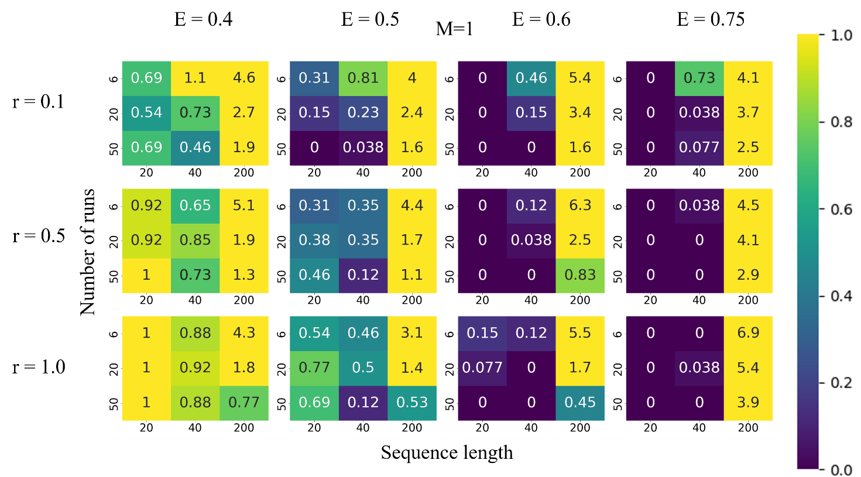

Figure S1. Accuracy of detection of epistatic pairs from UFE correlator for $M=1$. Simulation parameters and notation are as in Figure 1.
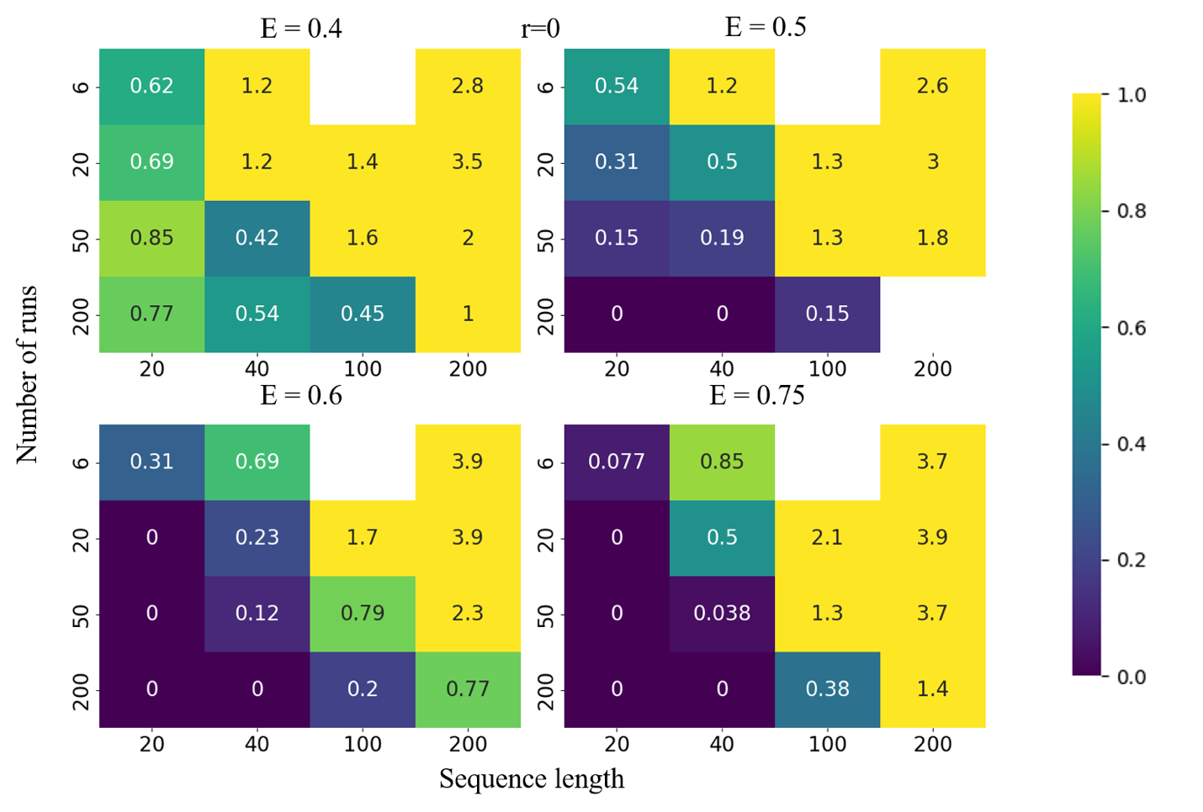

Figure S2. The error of detection of epistatic interactions from UFE correlator in the absence of recombination. Simulation parameters and notation as in Figure 1.
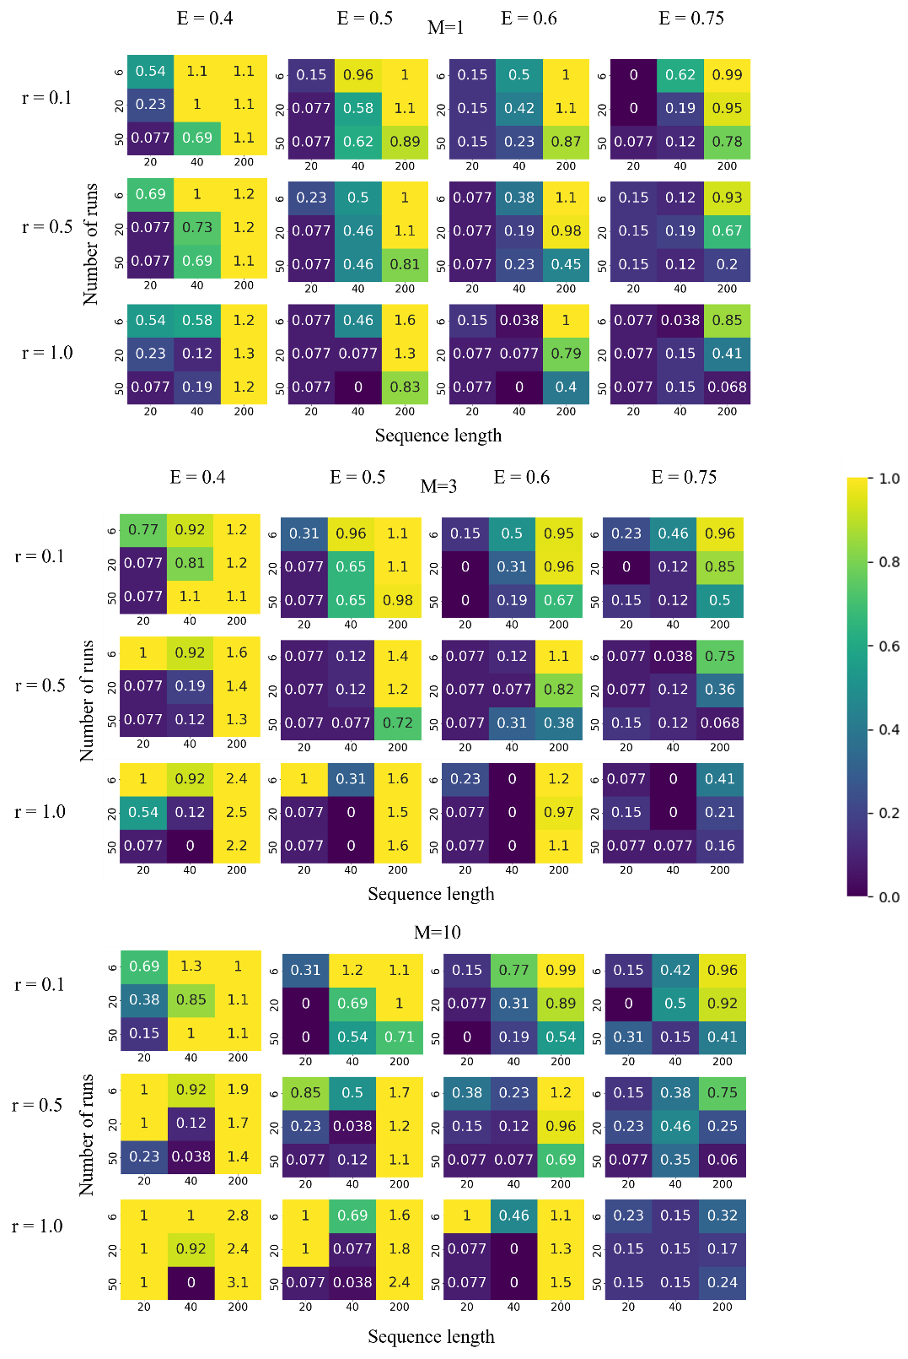

Figure S3. The error of detection of epistatic interactions from Pearson coefficient. Simulation parameters and notation as in Figure 1.
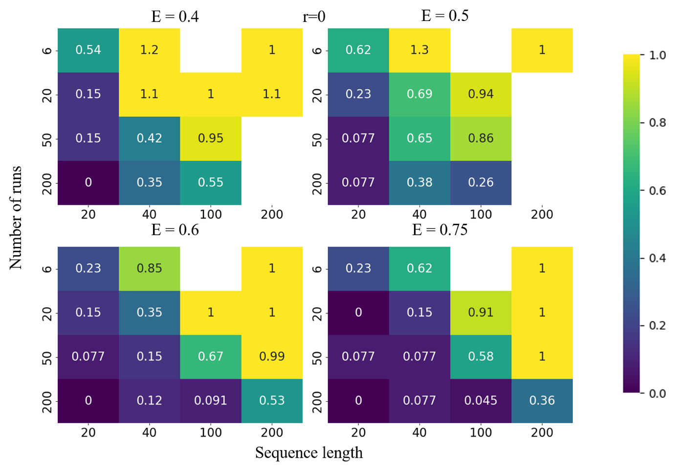

Figure S4. The error of detection of epistatic interactions in the absence of recombination from Pearson coefficient. Simulation parameters and notation are as in Figure 1.
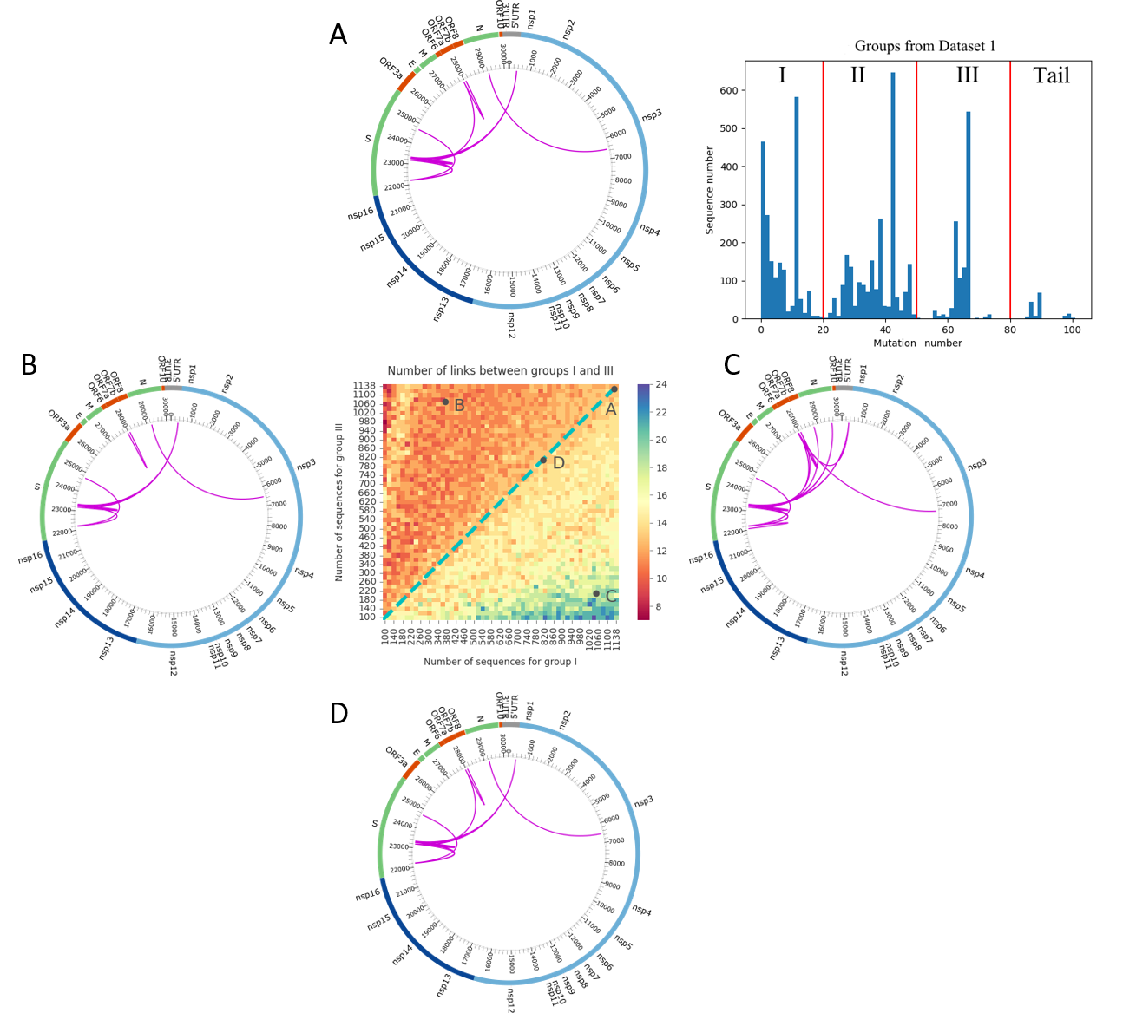

Figure S5. The variant of Fig. 4 without the sequences of the peak at 90 in Fig. 2.
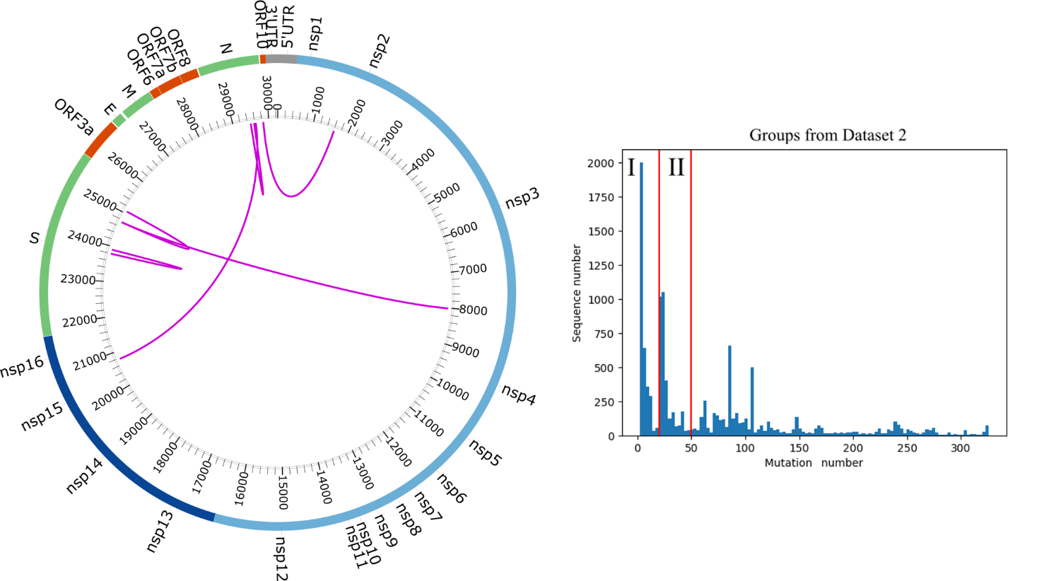

Figure S6. Epistatic interactions for SARS-CoV-2 genome predicted for Dataset 2 from UFE correlator between groups I and II in the mutation spectrum on the right. Dataset 2 was constructed downloading 12,000 sequences from NCBI Virus database labeled B.1 and B.1.1.7 (Alpha), in equal numbers each.

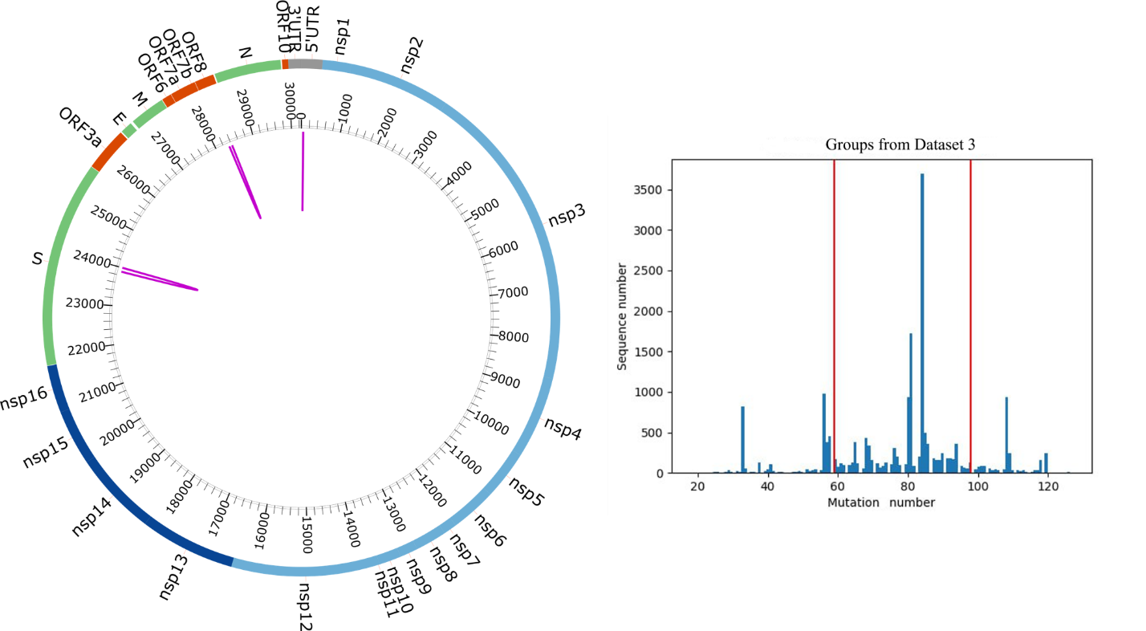

Figure S7. Epistatic interactions for SARS-CoV-2 genome predicted for Dataset 3 from UFE correlator. Dataset 3 was constructed using 20,000 random sequences from the NCBI. Virus database for the period from 09/24/2020 to 09/25/2021. Calculations were based on a single central peak marked with the red lines.

1. Carlborg O, Jacobsson L, Ahgren P, Siegel P, Andersson L. Epistasis and the release of genetic variation during long-term selection. Nat Genet. 2006;38(4):418-20. Epub 2006/03/15. doi: 10.1038/ng1761. PubMed PMID: 16532011.
2. Zuk O, Hechter E, Sunyaev SR, Lander ES. The mystery of missing heritability: Genetic interactions create phantom heritability. Proc Natl Acad Sci U S A. 2012;109(4):1193-8. Epub 2012/01/10. doi: 10.1073/pnas.1119675109. PubMed PMID: 22223662; PubMed Central PMCID: PMCPMC3268279.
3. Gonzalez-Ortega E, Ballana E, Badia R, Clotet B, Este JA. Compensatory mutations rescue the virus replicative capacity of VIRIP-resistant HIV-1. Antiviral Res. 2011;92(3):479-83. Epub 2011/10/27. doi: 10.1016/j.antiviral.2011.10.010. PubMed PMID: 22027647.
4. Handel A, Regoes RR, Antia R. The role of compensatory mutations in the emergence of drug resistance. PLoS Comput Biol. 2006;2(10):e137. Epub 2006/10/17. doi: 10.1371/journal.pcbi.0020137. PubMed PMID: 17040124; PubMed Central PMCID: PMCPMC1599768.
5. Levin BR, Perrot V, Walker N. Compensatory mutations, antibiotic resistance and the population genetics of adaptive evolution in bacteria. Genetics. 2000;154(3):985-97. Epub 2000/04/11. PubMed PMID: 10757748; PubMed Central PMCID: PMCPMC1460977.
6. Nijhuis M, Schuurman R, de Jong D, Erickson J, Gustchina E, Albert J, et al. Increased fitness of drug resistant HIV-1 protease as a result of acquisition of compensatory mutations during suboptimal therapy. AIDS. 1999;13(17):2349-59. Epub 1999/12/22. PubMed PMID: 10597776.
7. Piana S, Carloni P, Rothlisberger U. Drug resistance in HIV-1 protease: Flexibility-assisted mechanism of compensatory mutations. Protein Sci. 2002;11(10):2393-402. Epub 2002/09/19. doi: 10.1110/ps.0206702. PubMed PMID: 12237461; PubMed Central PMCID: PMCPMC2384161.
8. Weissman DB, Desai MM, Fisher DS, Feldman MW. The rate at which asexual populations cross fitness valleys. Theor Popul Biol. 2009;75(4):286-300. Epub 2009/03/17. doi: 10.1016/j.tpb.2009.02.006. PubMed PMID: 19285994; PubMed Central PMCID: PMCPMC2992471.
9. Liu D, Zuo T, Hora B, Song H, Kong W, Yu X, et al. Preexisting compensatory amino acids compromise fitness costs of a HIV-1 T cell escape mutation. Retrovirology. 2014;11:101. Epub 20141119. doi: 10.1186/s12977-014-0101-0. PubMed PMID: 25407514; PubMed Central PMCID: PMCPMC4264250.
10. Crawford H, Prado JG, Leslie A, Hue S, Honeyborne I, Reddy S, et al. Compensatory mutation partially restores fitness and delays reversion of escape mutation within the immunodominant HLA-B*5703-restricted Gag epitope in chronic human immunodeficiency virus type 1 infection. J Virol. 2007;81(15):8346-51. Epub 20070516. doi: 10.1128/JVI.00465-07. PubMed PMID: 17507468; PubMed Central PMCID: PMCPMC1951305.
11. Song H, Pavlicek JW, Cai F, Bhattacharya T, Li H, Iyer SS, et al. Impact of immune escape mutations on HIV-1 fitness in the context of the cognate transmitted/founder genome. Retrovirology. 2012;9:89. Epub 20121030. doi: 10.1186/1742-4690-9-89. PubMed PMID: 23110705; PubMed Central PMCID: PMCPMC3496648.
12. Rouzine IM, Coffin JM. Search for the mechanism of genetic variation in the pro gene of human immunodeficiency virus. J Virol. 1999;73(10):8167-78. Epub 1999/09/11. doi: 10.1128/JVI.73.10.8167-8178.1999. PubMed PMID: 10482567; PubMed Central PMCID: PMCPMC112834.
13. Rouzine IM. Evolutionary Mechanisms of the Emergence of the Variants of Concern of SARS-CoV-2. Viruses. 2025;17(2). Epub 20250130. doi: 10.3390/v17020197. PubMed PMID: 40006952; PubMed Central PMCID: PMCPMC11861269.
14. Carabelli AM, Peacock TP, Thorne LG, Harvey WT, Hughes J, Consortium C-GU, et al. SARS-CoV-2 variant biology: immune escape, transmission and fitness. Nat Rev Microbiol. 2023;21(3):162-77. Epub 20230118. doi: 10.1038/s41579-022-00841-7. PubMed PMID: 36653446; PubMed Central PMCID: PMCPMC9847462.
15. Shrestha LB, Foster C, Rawlinson W, Tedla N, Bull RA. Evolution of the SARS-CoV-2 omicron variants BA.1 to BA.5: Implications for immune escape and transmission. Rev Med Virol. 2022;32(5):e2381. Epub 20220720. doi: 10.1002/rmv.2381. PubMed PMID: 35856385; PubMed Central PMCID: PMCPMC9349777.
16. Cobey S, Larremore DB, Grad YH, Lipsitch M. Concerns about SARS-CoV-2 evolution should not hold back efforts to expand vaccination. Nat Rev Immunol. 2021;21(5):330-5. Epub 2021/04/03. doi: 10.1038/s41577-021-00544-9. PubMed PMID: 33795856; PubMed Central PMCID: PMCPMC8014893.
17. Yewdell JW. Antigenic drift: Understanding COVID-19. Immunity. 2021;54(12):2681-7. Epub 2021/12/16. doi: 10.1016/j.immuni.2021.11.016. PubMed PMID: 34910934; PubMed Central PMCID: PMCPMC8669911.
18. Rouzine IM, Rozhnova G. Evolutionary implications of SARS-CoV-2 vaccination for the future design of vaccination strategies. Commun Med (Lond). 2023;3(1):86. Epub 20230619. doi: 10.1038/s43856-023-00320-x. PubMed PMID: 37336956; PubMed Central PMCID: PMCPMC10279745.
19. Moulana A, Dupic T, Phillips AM, Chang J, Nieves S, Roffler AA, et al. Compensatory epistasis maintains ACE2 affinity in SARS-CoV-2 Omicron BA.1. Nat Commun. 2022;13(1):7011. Epub 20221116. doi: 10.1038/s41467-022-34506-z. PubMed PMID: 36384919; PubMed Central PMCID: PMCPMC9668218.
20. Harari S, Tahor M, Rutsinsky N, Meijer S, Miller D, Henig O, et al. Drivers of adaptive evolution during chronic SARS-CoV-2 infections. Nat Med. 2022;28(7):1501-8. Epub 20220620. doi: 10.1038/s41591-022-01882-4. PubMed PMID: 35725921; PubMed Central PMCID: PMCPMC9307477.
21. Reuschl AK, Thorne LG, Whelan MVX, Ragazzini R, Furnon W, Cowton VM, et al. Evolution of enhanced innate immune suppression by SARS-CoV-2 Omicron subvariants. Nat Microbiol. 2024;9(2):451-63. Epub 20240116. doi: 10.1038/s41564-023-01588-4. PubMed PMID: 38228858; PubMed Central PMCID: PMCPMC10847042.
22. Thorne LG, Bouhaddou M, Reuschl AK, Zuliani-Alvarez L, Polacco B, Pelin A, et al. Evolution of enhanced innate immune evasion by SARS-CoV-2. Nature. 2022;602(7897):487-95. Epub 20211223. doi: 10.1038/s41586-021-04352-y. PubMed PMID: 34942634; PubMed Central PMCID: PMCPMC8850198.
23. Adams RM, Kinney JB, Walczak AM, Mora T. Epistasis in a Fitness Landscape Defined by Antibody-Antigen Binding Free Energy. Cell Syst. 2019;8(1):86-93 e3. Epub 20190102. doi: 10.1016/j.cels.2018.12.004. PubMed PMID: 30611676; PubMed Central PMCID: PMCPMC6487650.
24. Lyons DM, Zou Z, Xu H, Zhang J. Idiosyncratic epistasis creates universals in mutational effects and evolutionary trajectories. Nat Ecol Evol. 2020;4(12):1685-93. Epub 20200907. doi: 10.1038/s41559-020-01286-y. PubMed PMID: 32895516; PubMed Central PMCID: PMCPMC7710555.
25. Chen CC, Schwender H, Keith J, Nunkesser R, Mengersen K, Macrossan P. Methods for identifying SNP interactions: a review on variations of Logic Regression, Random Forest and Bayesian logistic regression. IEEE/ACM Trans Comput Biol Bioinform. 2011;8(6):1580-91. Epub 2011/03/09. doi: 10.1109/TCBB.2011.46. PubMed PMID: 21383421.
26. Cordell HJ. Detecting gene-gene interactions that underlie human diseases. Nature reviews Genetics. 2009;10(6):392-404. doi: 10.1038/nrg2579. PubMed PMID: PMC2872761.
27. Ueki M, Cordell HJ. Improved statistics for genome-wide interaction analysis. PLoS Genet. 2012;8(4):e1002625. Epub 2012/04/13. doi: 10.1371/journal.pgen.1002625. PubMed PMID: 22496670; PubMed Central PMCID: PMCPMC3320596.
28. Kimura M. Attainment of Quasi Linkage Equilibrium When Gene Frequencies Are Changing by Natural Selection. Genetics. 1965;52(5):875-90. doi: 10.1093/genetics/52.5.875. PubMed PMID: 17248281; PubMed Central PMCID: PMCPMC1210959.
29. Weigt M, White RA, Szurmant H, Hoch JA, Hwa T. Identification of direct residue contacts in protein-protein interaction by message passing. Proc Natl Acad Sci U S A. 2009;106(1):67-72. Epub 2009/01/01. doi: 10.1073/pnas.0805923106. PubMed PMID: 19116270; PubMed Central PMCID: PMCPMC2629192.
30. Neher RA, Shraiman BI. Statistical genetics and evolution of quantitative traits. Reviews of Modern Physics. 2011;83:1283.
31. Louie RHY, Kaczorowski KJ, Barton JP, Chakraborty AK, McKay MR. Fitness landscape of the human immunodeficiency virus envelope protein that is targeted by antibodies. Proc Natl Acad Sci U S A. 2018;115(4):E564-E73. Epub 20180108. doi: 10.1073/pnas.1717765115. PubMed PMID: 29311326; PubMed Central PMCID: PMCPMC5789945.
32. Wei W-H, Hemani G, Haley CS. Detecting epistasis in human complex traits. Nature Reviews Genetics. 2014;15:722. doi: 10.1038/nrg3747
https://www.nature.com/articles/nrg3747#supplementary-information.
33. Fisher RA. The genetical theory of natural selection. Oxford, United Kingdom: Clarendon Press, 1958; 1930.
34. Pedruzzi G, Rouzine IM. Epistasis detectably alters correlations between genomic sites in a narrow parameter window. PLoS One. 2019;14(5):e0214036. Epub 2019/06/01. doi: 10.1371/journal.pone.0214036. PubMed PMID: 31150393; PubMed Central PMCID: PMCPMC6544209.
35. Rouzine IM. Long-range linkage effects in adapting sexual populations. Sci Rep. 2023;13(1):12492. Epub 20230801. doi: 10.1038/s41598-023-39392-z. PubMed PMID: 37528175; PubMed Central PMCID: PMCPMC10393966.
36. Pedruzzi G, Barlukova A, Rouzine IM. Evolutionary footprint of epistasis. PLoS Comput Biol. 2018;14(9):e1006426. Epub 2018/09/18. doi: 10.1371/journal.pcbi.1006426. PubMed PMID: 30222748; PubMed Central PMCID: PMCPMC6177197.
37. Kryazhimskiy S, Dushoff J, Bazykin GA, Plotkin JB. Prevalence of epistasis in the evolution of influenza A surface proteins. PLoS Genet. 2011;7(2):e1001301. Epub 20110217. doi: 10.1371/journal.pgen.1001301. PubMed PMID: 21390205; PubMed Central PMCID: PMCPMC3040651.
38. Neverov AD, Kryazhimskiy S, Plotkin JB, Bazykin GA. Coordinated Evolution of Influenza A Surface Proteins. PLoS Genet. 2015;11(8):e1005404. Epub 20150806. doi: 10.1371/journal.pgen.1005404. PubMed PMID: 26247472; PubMed Central PMCID: PMCPMC4527594.
39. Pedruzzi G, Rouzine IM. An evolution-based high-fidelity method of epistasis measurement: Theory and application to influenza. PLoS Pathog. 2021;17(6):e1009669. Epub 2021/06/22. doi: 10.1371/journal.ppat.1009669. PubMed PMID: 34153082; PubMed Central PMCID: PMCPMC8248644.
40. Bonhoeffer S, Chappey C, Parkin NT, Whitcomb JM, Petropoulos CJ. Evidence for positive epistasis in HIV-1. Science. 2004;306(5701):1547-50. doi: 10.1126/science.1101786. PubMed PMID: 15567861.
41. Zhang TH, Dai L, Barton JP, Du Y, Tan Y, Pang W, et al. Predominance of positive epistasis among drug resistance-associated mutations in HIV-1 protease. PLoS Genet. 2020;16(10):e1009009. Epub 20201021. doi: 10.1371/journal.pgen.1009009. PubMed PMID: 33085662; PubMed Central PMCID: PMCPMC7605711.
42. Althaus CL, De Boer RJ. Dynamics of immune escape during HIV/SIV infection. PLoS Comput Biol. 2008;4(7):e1000103. Epub 20080718. doi: 10.1371/journal.pcbi.1000103. PubMed PMID: 18636096; PubMed Central PMCID: PMCPMC2423483.
43. Batorsky R, Sergeev RA, Rouzine IM. The route of HIV escape from immune response targeting multiple sites is determined by the cost-benefit tradeoff of escape mutations. PLoS Comput Biol. 2014;10(10):e1003878. Epub 2014/10/31. doi: 10.1371/journal.pcbi.1003878. PubMed PMID: 25356981; PubMed Central PMCID: PMCPMC4214571.
44. Smith CA, Ashby B. Antigenic evolution of SARS-CoV-2 in immunocompromised hosts. Evol Med Public Health. 2023;11(1):90-100. Epub 20221111. doi: 10.1093/emph/eoac037. PubMed PMID: 37007166; PubMed Central PMCID: PMCPMC10061940.
45. Rouzine IM. Mathematical Modeling of Evolution. Volume 1. One-Locus and Multi-Locus Theory and Recombination. Berlin: De Gruyter; 2020.
46. Rouzine IM. Mathematical Models of Evolution. Volume 2: Fitness Landscape, Red Queen, Evolutionary Enigmas, and Applications to Virology. Berlin/Boston: De Gruyter; 2023. 305 p.
47. Rouzine IM, Weinberger LS. The quantitative theory of within-host viral evolution. J Stat Mech: Theory and Experiment. 2013;2013. doi: 10.1088/1742-5468/2013/01/P01009.
48. Rouzine IM, Rozhnova G. Antigenic evolution of viruses in host populations. PLoS Pathog. 2018;14(9):e1007291. Epub 2018/09/13. doi: 10.1371/journal.ppat.1007291. PubMed PMID: 30208108; PubMed Central PMCID: PMCPMC6173453.
49. Yan L, Neher RA, Shraiman BI. Phylodynamic theory of persistence, extinction and speciation of rapidly adapting pathogens. Elife. 2019;8. Epub 2019/09/19. doi: 10.7554/eLife.44205. PubMed PMID: 31532393; PubMed Central PMCID: PMCPMC6809594.
50. Marchi J, Lassig M, Walczak AM, Mora T. Antigenic waves of virus-immune coevolution. Proc Natl Acad Sci U S A. 2021;118(27). Epub 2021/06/30. doi: 10.1073/pnas.2103398118. PubMed PMID: 34183397; PubMed Central PMCID: PMCPMC8271616.
51. Muller HG. Some genetic aspects of sex. American Naturalist. 1932;66:118-28.
52. Rice S. Evolutionary Theory: Mathematical and Conceptual Foundations. : Sinauer Associated; 2004.
53. Felsenstein J. The evolutionary advantage of recombination. Genetics. 1974;78(2):737-56. doi: 10.1093/genetics/78.2.737. PubMed PMID: 4448362; PubMed Central PMCID: PMCPMC1213231.
54. Rouzine IM, Wakeley J, Coffin JM. The solitary wave of asexual evolution. Proc Natl Acad Sci U S A. 2003;100(2):587-92. Epub 2003/01/15. doi: 10.1073/pnas.242719299. PubMed PMID: 12525686; PubMed Central PMCID: PMC141040.
55. Hill WG, Robertson A. The effect of linkage on limits to artificial selection. Genet Res. 1966;8(3):269-94. Epub 1966/12/01. PubMed PMID: 5980116.
56. Gerrish PJ, Lenski RE. The fate of competing beneficial mutations in an asexual population. Genetica. 1998;102-103(1-6):127-44. Epub 1998/08/28. PubMed PMID: 9720276.
57. Desai MM, Fisher DS. Beneficial mutation selection balance and the effect of linkage on positive selection. Genetics. 2007;176(3):1759-98. Epub 2007/05/08. doi: 10.1534/genetics.106.067678. PubMed PMID: 17483432; PubMed Central PMCID: PMCPMC1931526.
58. Hallatschek O. The noisy edge of traveling waves. Proc Natl Acad Sci U S A. 2010;108(5):1783-7. PubMed PMID: 21187435.
59. Rodriguez-Rivas J, Croce G, Muscat M, Weigt M. Epistatic models predict mutable sites in SARS-CoV-2 proteins and epitopes. Proc Natl Acad Sci U S A. 2022;119(4). Epub 2022/01/14. doi: 10.1073/pnas.2113118119. PubMed PMID: 35022216; PubMed Central PMCID: PMCPMC8795541.
60. Zeng H-L, Dichio V, Rodríguez Horta E, Thorell K, Aurell E. Global analysis of more than 50,000 SARS-CoV-2 genomes reveals epistasis between eight viral genes. Proceedings of the National Academy of Sciences. 2020;117(49):31519-26. doi: doi:10.1073/pnas.2012331117.
61. Batorsky R, Kearney MF, Palmer SE, Maldarelli F, Rouzine IM, Coffin JM. Estimate of effective recombination rate and average selection coefficient for HIV in chronic infection. Proc Natl Acad Sci U S A. 2011;108(14):5661-6. Epub 2011/03/26. doi: 1102036108 [pii]
10.1073/pnas.1102036108. PubMed PMID: 21436045; PubMed Central PMCID: PMC3078368.
62. Estimating fitness effects of mutations in the presence of genetic linkage [Internet]. 2025. Available from: https://www.biorxiv.org/content/10.1101/2025.11.26.690712v1.
63. Katoh K, Rozewicki J, Yamada KD. MAFFT online service: multiple sequence alignment, interactive sequence choice and visualization. Brief Bioinform. 2019;20(4):1160-6. doi: 10.1093/bib/bbx108. PubMed PMID: 28968734; PubMed Central PMCID: PMCPMC6781576.
64. Rouzine IM, Coffin JM. Evolution of human immunodeficiency virus under selection and weak recombination. Genetics. 2005;170(1):7-18. Epub 2005/03/04. doi: 10.1534/genetics.104.029926. PubMed PMID: 15744057; PubMed Central PMCID: PMCPMC1449738.
65. Neher RA, Leitner T. Recombination rate and selection strength in HIV intra-patient evolution. PLoS Comput Biol. 2010;6(1):e1000660. Epub 2010/02/04. doi: 10.1371/journal.pcbi.1000660. PubMed PMID: 20126527; PubMed Central PMCID: PMC2813257.
66. Rast LI, Rouzine IM, Rozhnova G, Bishop L, Weinberger AD, Weinberger LS. Conflicting Selection Pressures Will Constrain Viral Escape from Interfering Particles: Principles for Designing Resistance-Proof Antivirals. PLoS Comput Biol. 2016;12(5):e1004799. Epub 20160506. doi: 10.1371/journal.pcbi.1004799. PubMed PMID: 27152856; PubMed Central PMCID: PMCPMC4859541.

